Completing Your SAE Plan
Use these instructions to complete your SAE plan. Be sure to follow them carefully to make sure you don’t miss a step!
- Go to www.theaet.com and log on using your login credentials.
- Click “Profile.”
- Click “Experience Manager.”
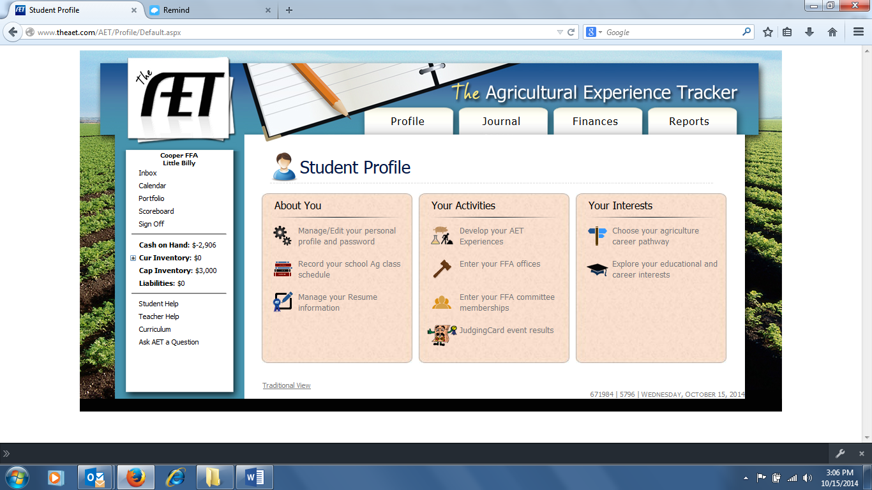
- If there are no experience listed in this section, Click “Add New.” If there are experience already listed that you are happy with, proceed to step __________.
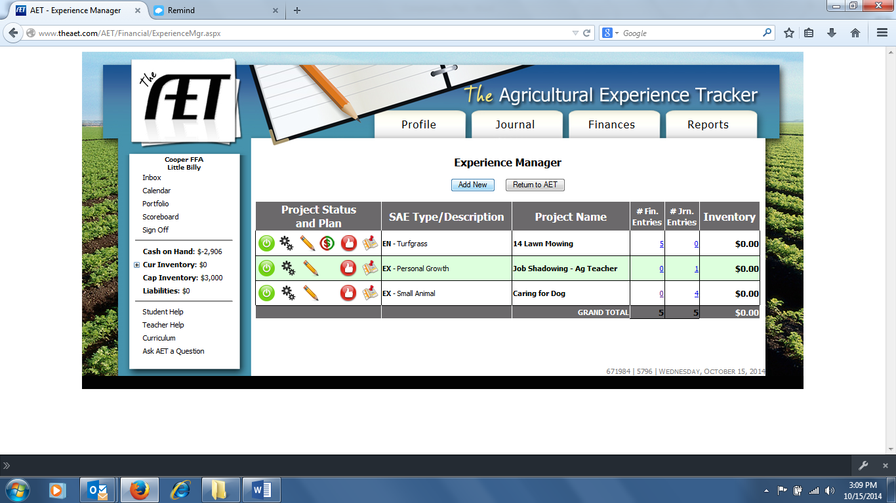
- Complete each separate field for your SAE including:
  - Name (give the PROJECT a name; this is not your name)
  - SAE Type (You will only select one from the 7 options listed)
  - Primary Experience Category
  - Primary Subcategory
    - For a very in depth SAE, you may have multiple SAE projects that you create and keep records on separately. For this class, you only have to have one project.
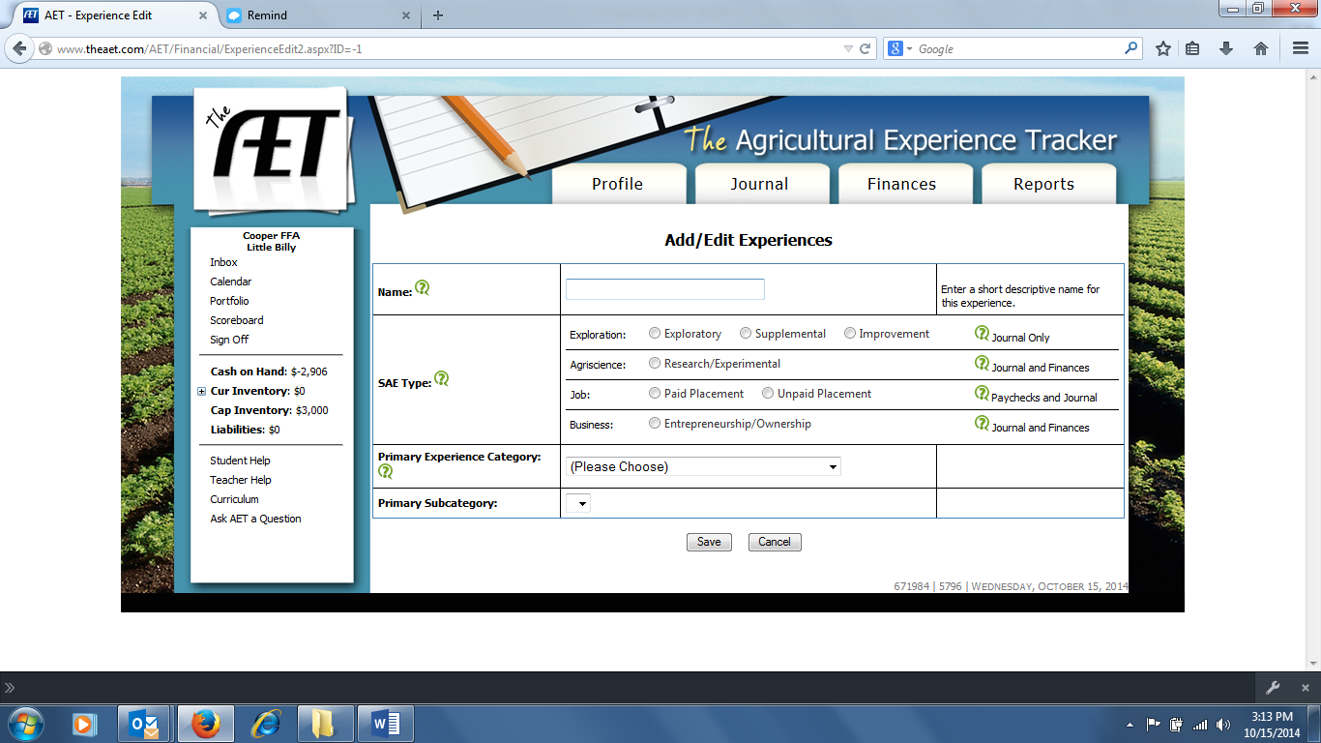
- Make sure to save your experience! This should then return you to your “Experience Manager.” If not, follow steps 1-4 to get back to your “Experience Manager.”
- To complete your SAE plan, you will click the pencil that corresponds to the SAE that you wish to create the plan for.
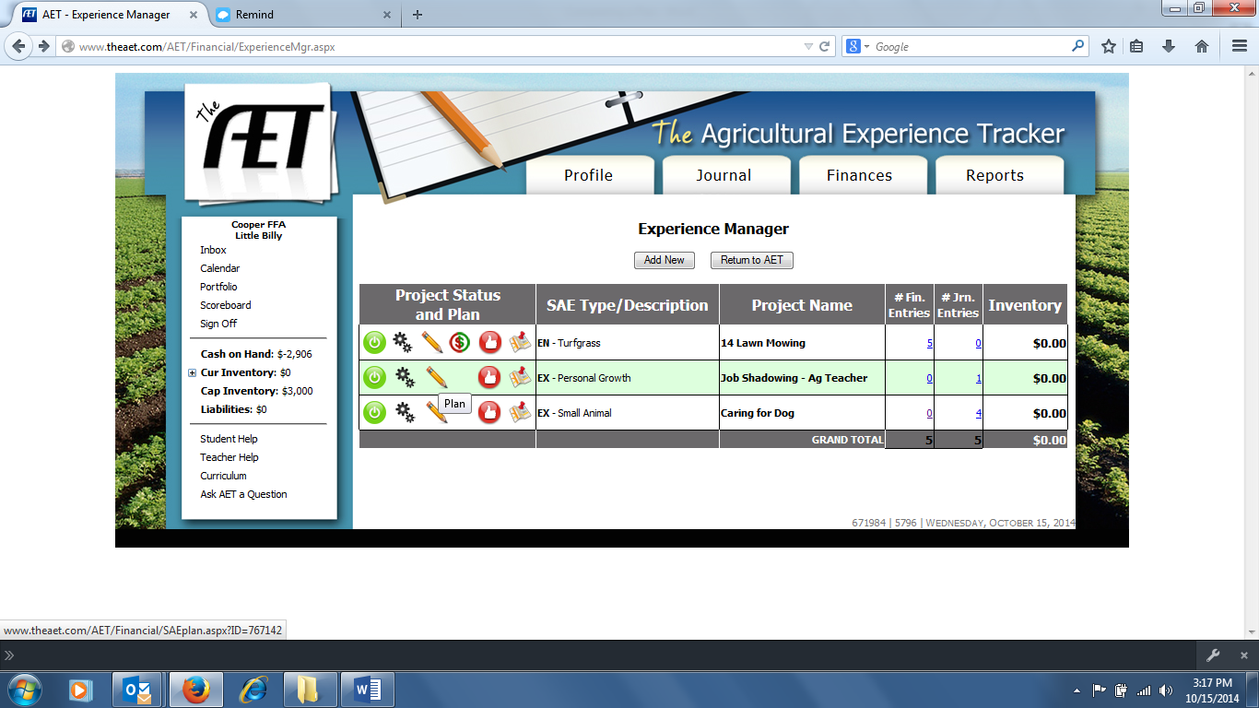
- Once on the plan page, you should complete each highlighted tab. Be as descriptive as possible. Your description should be about 1 paragraph in length. Time Investment and Goals will only be a few sentences. Financial and Capital Investment will vary from project to project.
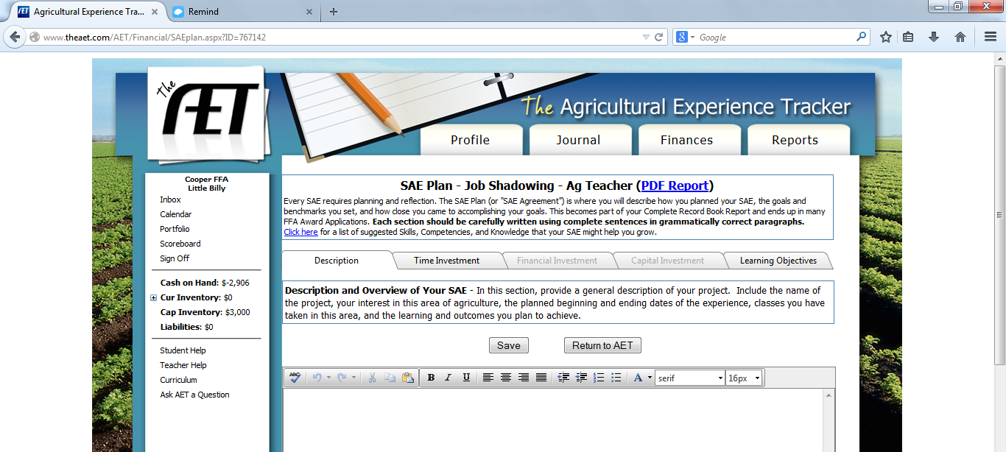
- Once your plan is completed, you should either print your plan or email it to Mr. White. To do so, you will click on the “PDF Report” at the top of the page. This will download a PDF of your document. From there, either print the PDF or email it to Mr. White at cameron.white@boone.kyschools.us

